Helping to SING for Altruism
(Struggle with a task, Inquire for help, Notice times when child helps, Give help overtly)


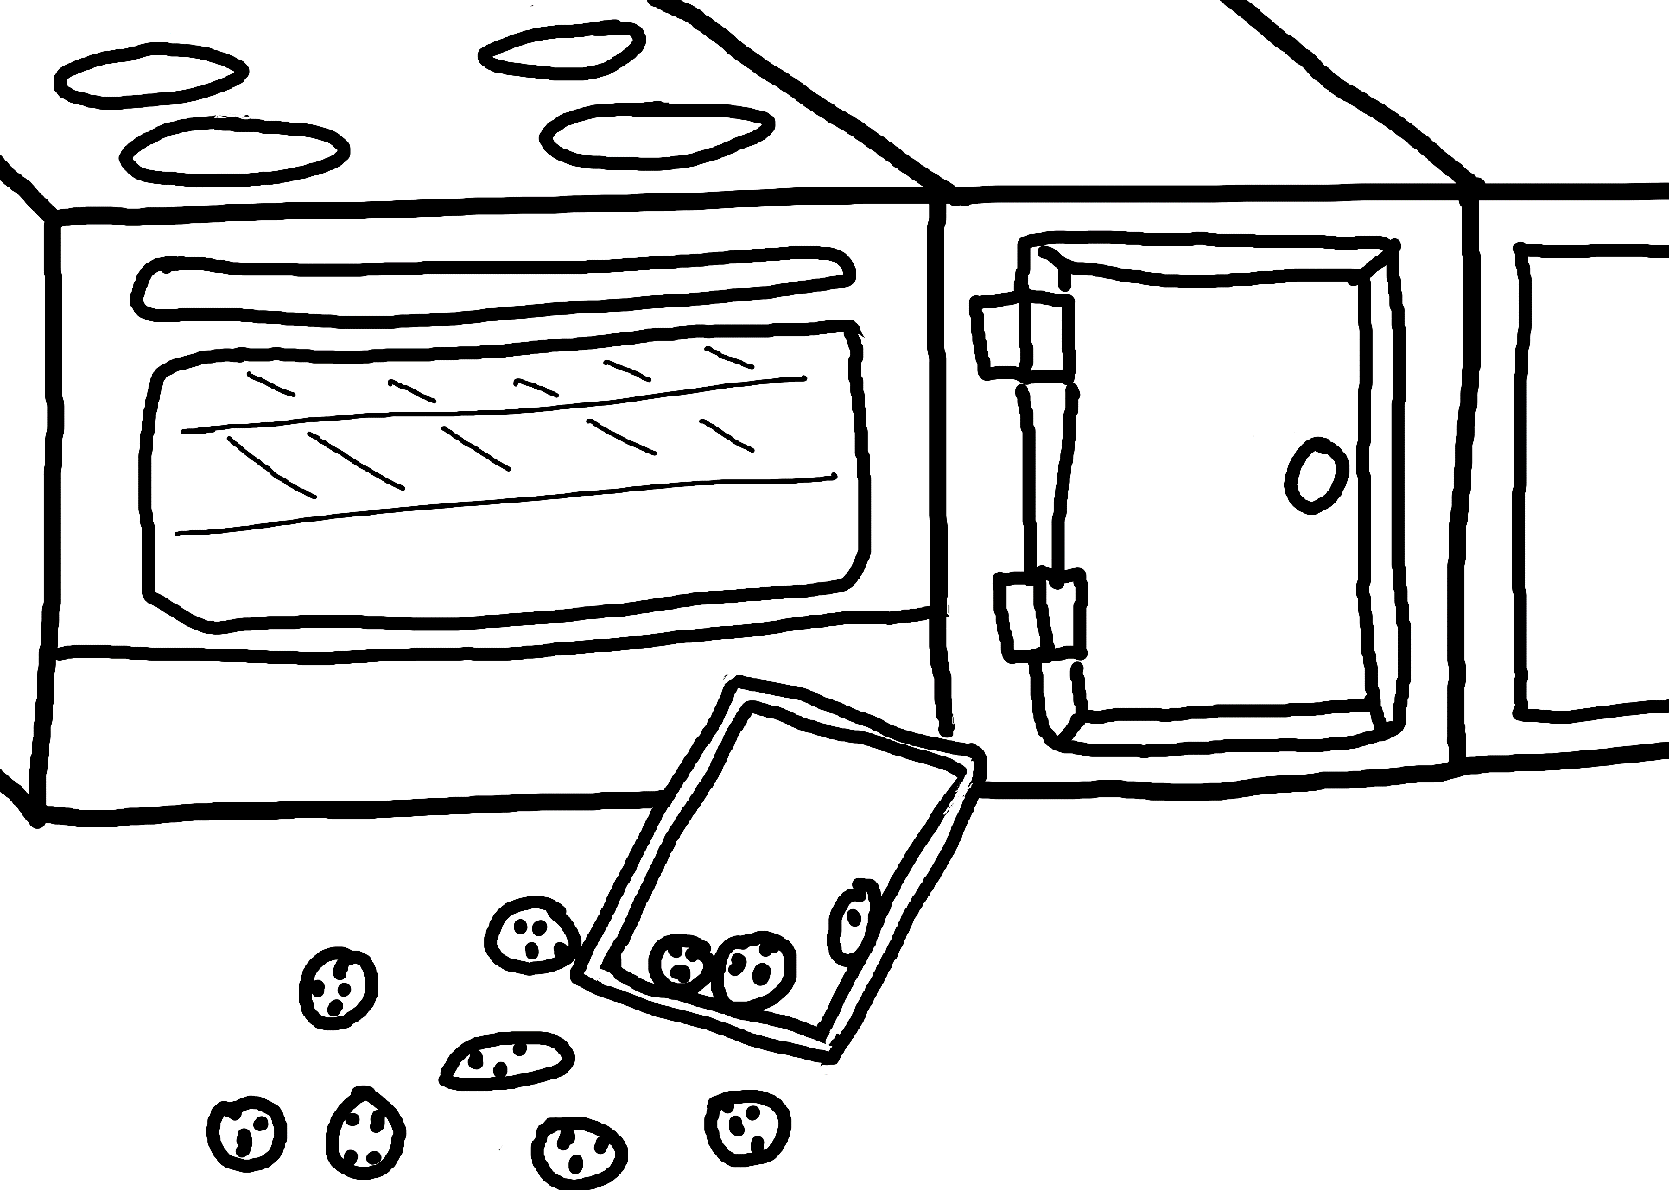

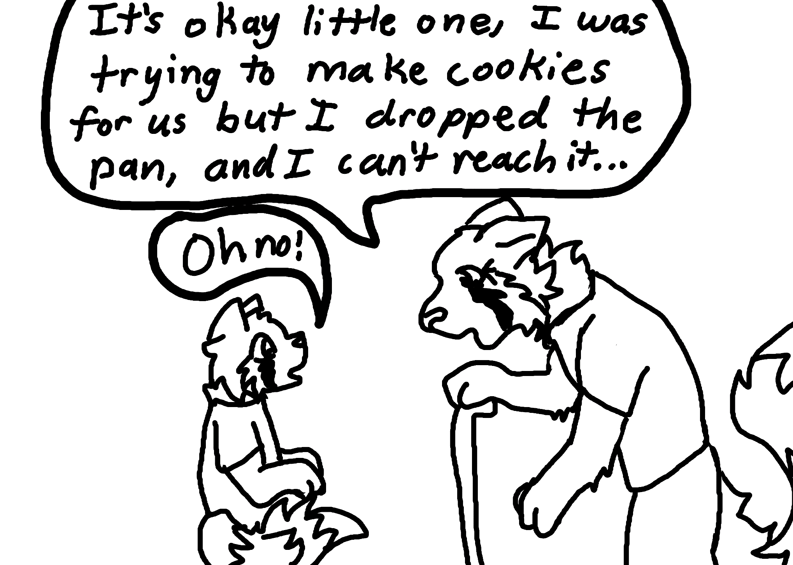

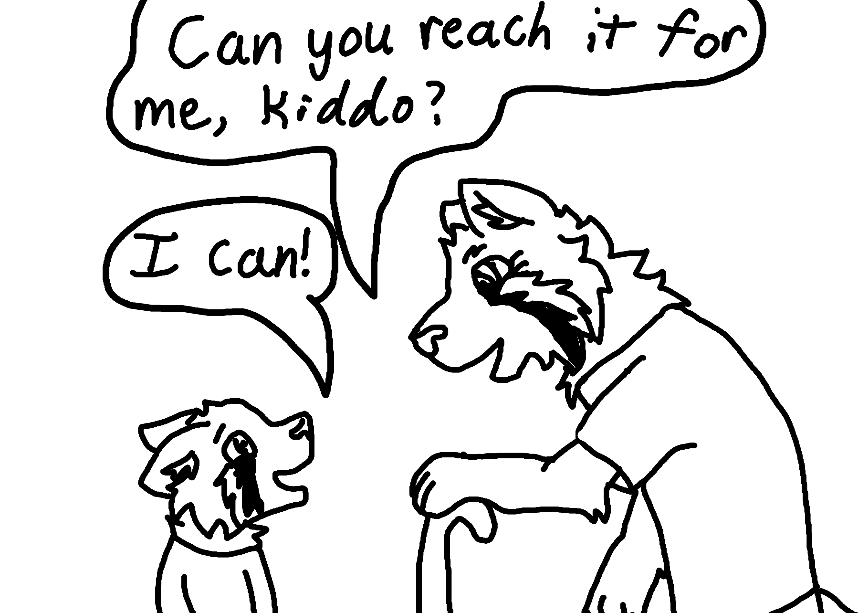
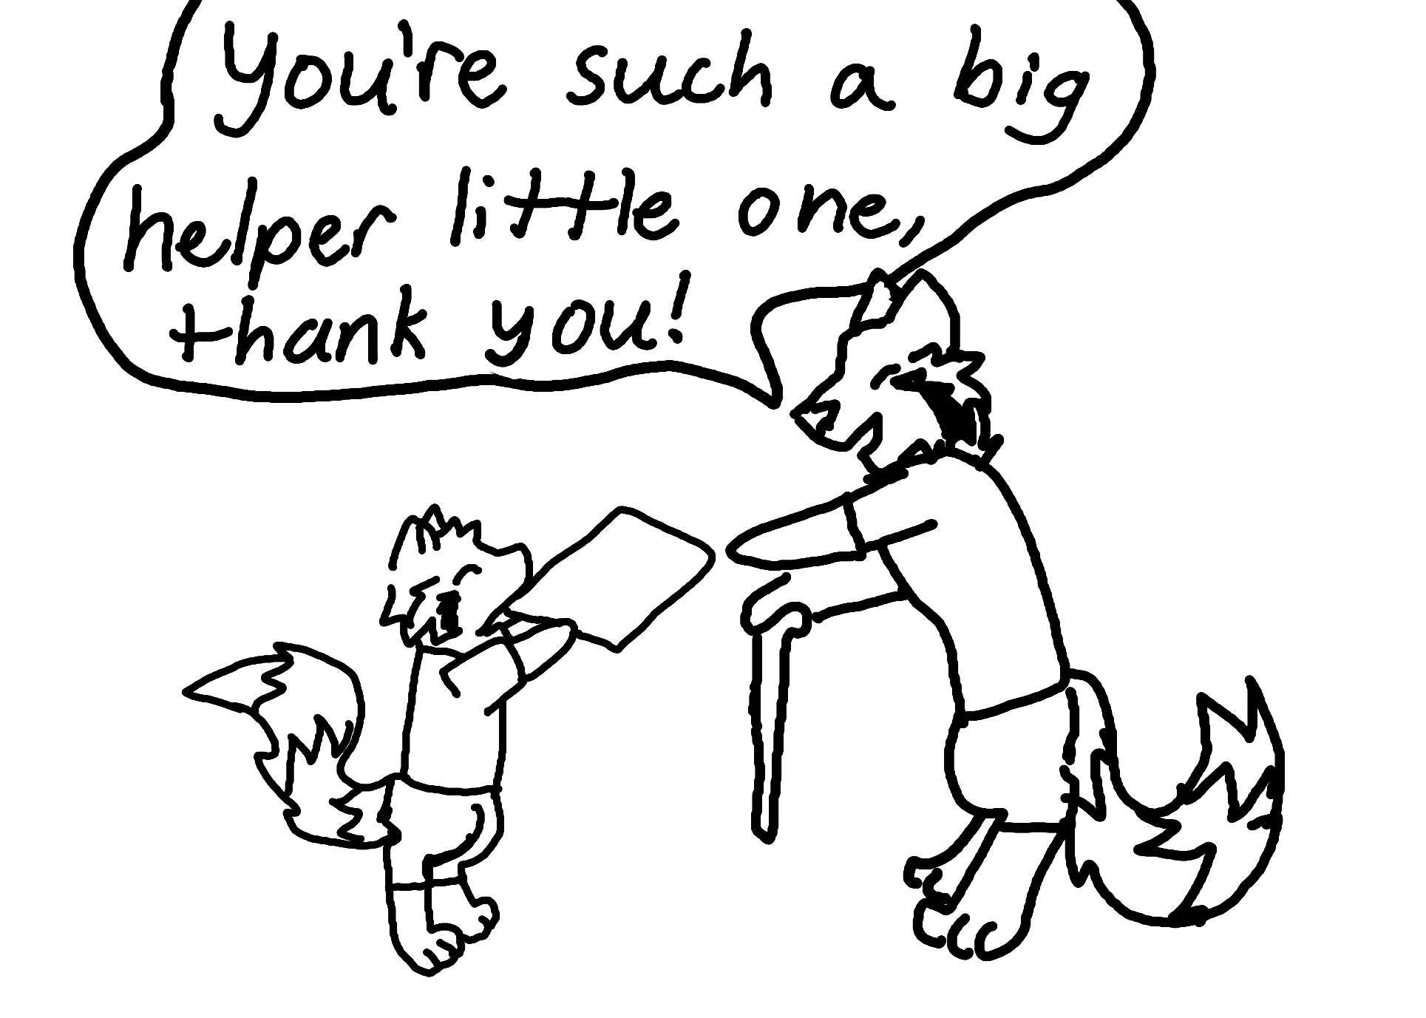

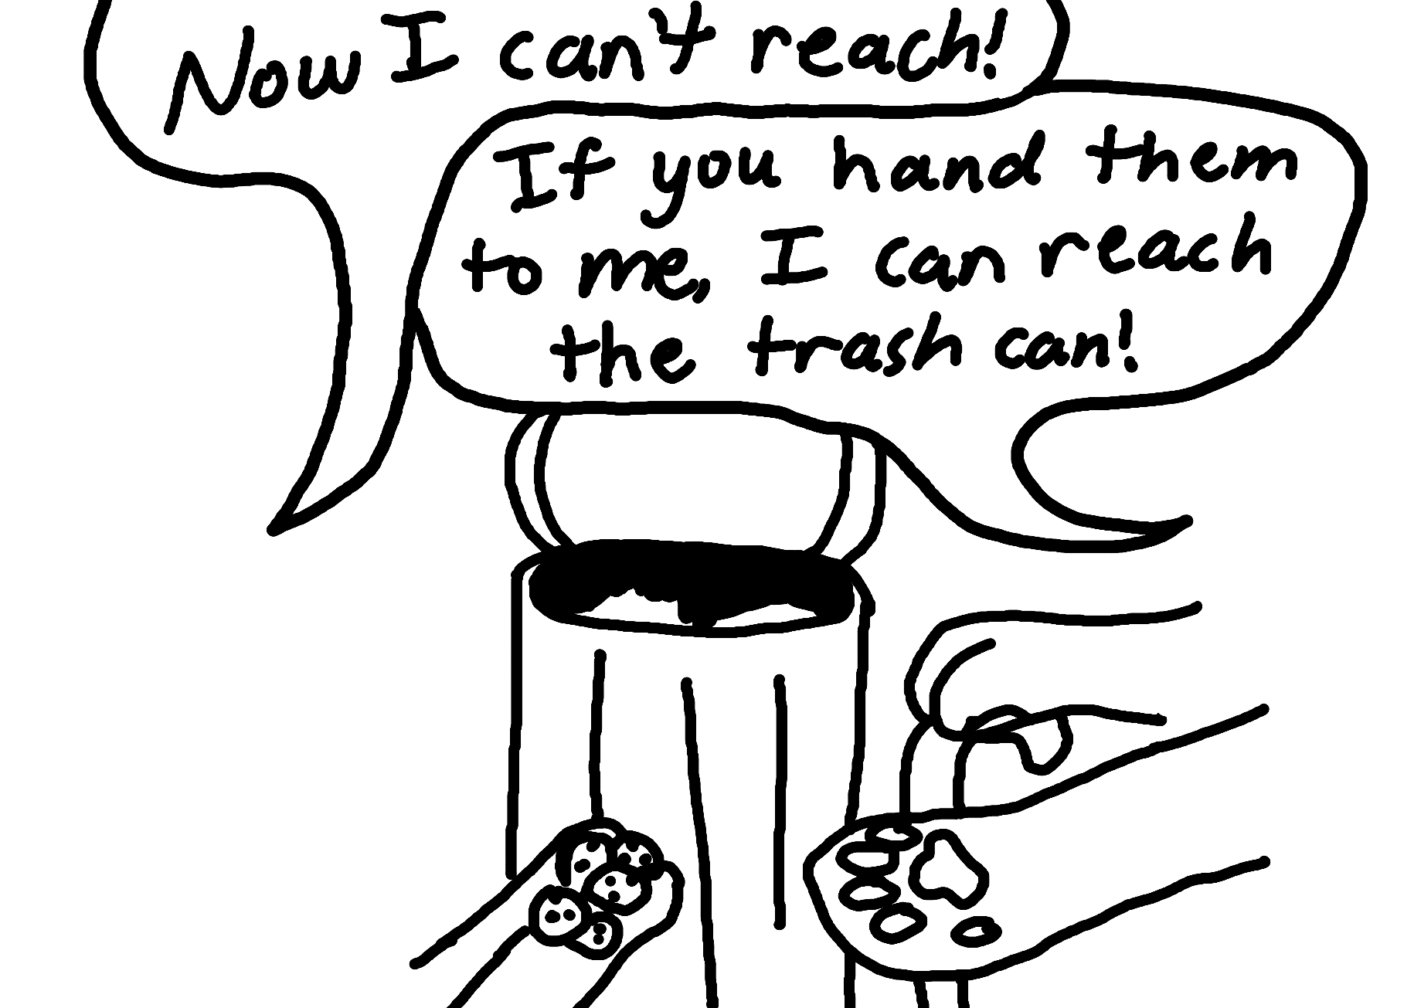
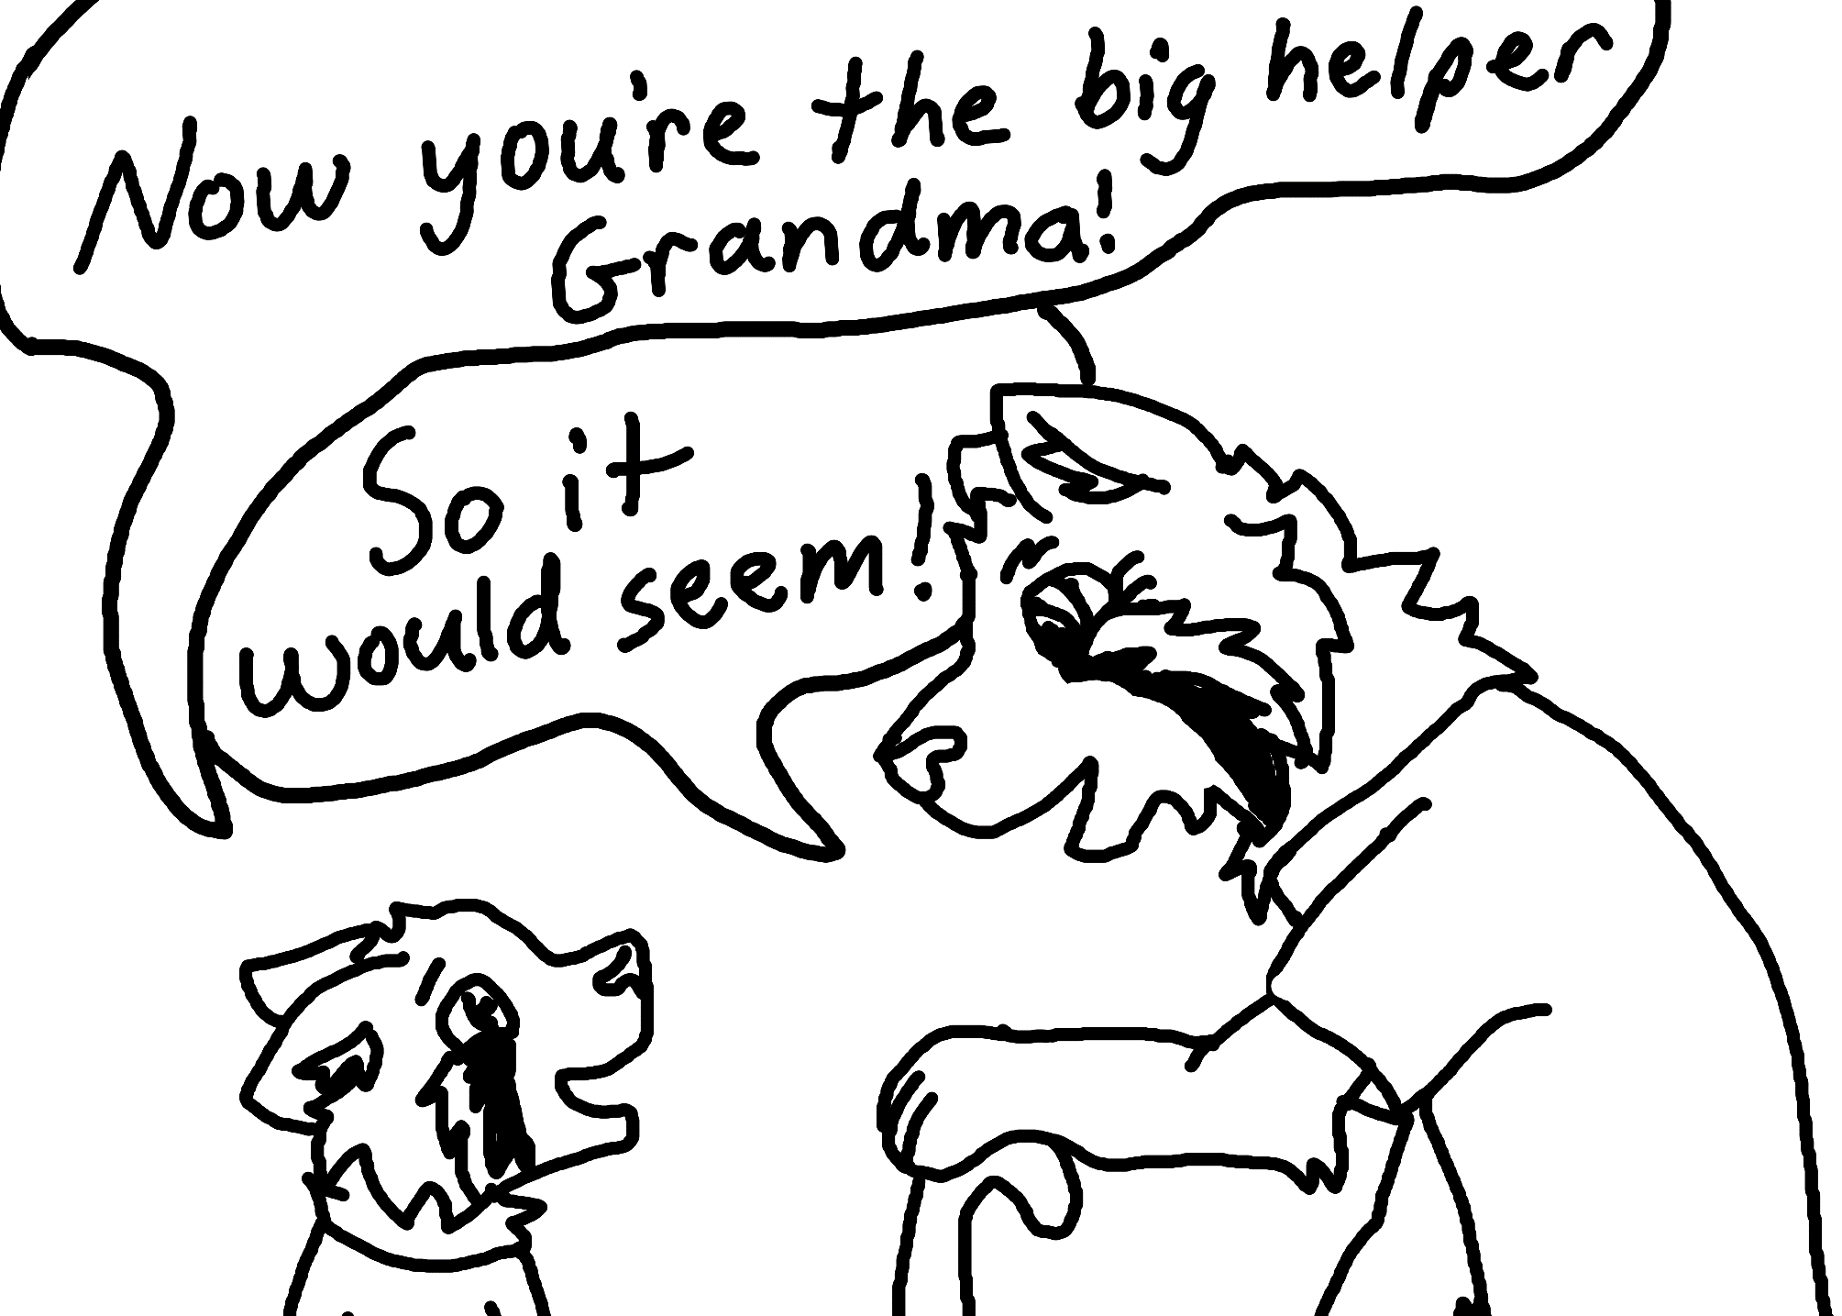
Helping to SING for Altruism

Struggle | Struggle with a task in front of the child, and see if the child will help independently. | “Hmm…I can’t get these Lego’s apart.”  “I can’t quite reach that book.”
Inquire | Inquire for help by directly asking if the child doesn’t help independently. | “I can’t get these Lego’s apart…can you try?”  “Could you hand me that book?”
Notice | Notice times when the child helps by saying thank you or using praise. | “Thank you so much for helping me with the Legos.”  “You are such a big helper.”
Give | Give help overtly to child when and point out you are helping. | “It’s really hard to get those Lego’s apart…can I try?”  “Here’s a book that you might like.”

Use proactive teaching to encourage empathy and helping behaviors.

